**What challenges or bugs did you encounter and how did you overcome the challenges?**

The biggest challenge I’ve faced when making this website was to format my header. Adjusting the distance between different elements and making things align the way I wanted took a lot of patience to achieve. To make the elements in the header inline, I first tried to use flex box but I had a hard time moving my shopping cart icon to the right of the page. After asking others in the cohort and google, I succeeded by using “display: inline” and “float: right”.

Another thing that I learnt from making this website and testing the code using the w3school validators was that I have been using id the wrong way. As shown in the screen shot below, I gave all the <div> elements the id “thumb_nail_img”. The code ran fine, but when I put in the html validator, it told me that I shouldn’t assign the same id to multiple elements. Then I finally understood the difference between class and id, and was able to correct my code. If I haven’t used the validator, I might never know that I was doing it wrong the wrong.

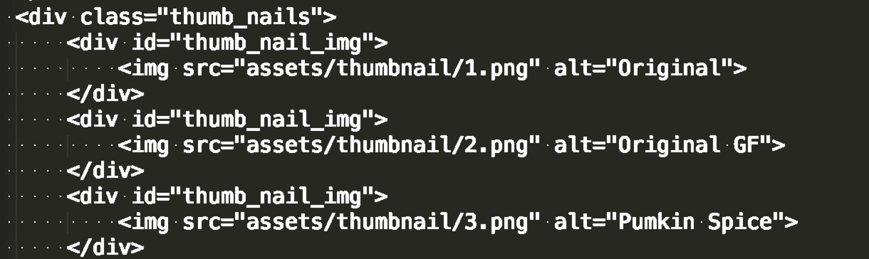

Figure 1 My errors that were reported by the HTML validator

**How is the brand identity of your client reflected through your design choices?**

**What kind of look and feel did you design for them and why?**

Bun Bun Bake Shop is a local bake shop in Pittsburgh that sells handmade artisan cinnamon rolls. The brands’ unique selling point is that its products are handmade and fresh. I included many hi-res images into my design. Instead of using words, I hoped that the pictures of the buns can talk for themselves and attract the customers to make a purchase.

In the product browsing page the links that leads to each product page are all full bleed images of the bun. I plan to add a hover function to these thumb nails later using JavaScript. So when the user hovers onto a single image, he/she would see the name of the product and a price.